- Test Dataset: 10100AA158003
S‐158 Recommended ENC Validation Checks covered in this section:
S‐158 Check | Description
101_1025 | For each DataCoverage which OVERLAPS OR is WITHIN another DataCoverage.
101_0004 | For each curve segment referenced by only one DataCoverage AND is also shared by more than one Skin of the Earth feature.
101_1182 | For each Gate where verticalClearanceOpen.verticalClearanceUnlimited is False and verticalClearanceOpen.verticalClearanceValue is not Present
101_1204 | For each DepthContour which does not share a curve with a Skin of the Earth feature AND is WITHIN a DredgedArea where depthRangeMinimumValue is Known AND valueOfDepthContour is Less than depthRangeMinimumValue.
101_1209 | For each DepthContour which CROSSES another DepthContour. Instances where the point of intersection is an intermediate vertex or node, and where one DepthContour does not cross to the other side of the other DepthContour, are excluded.
101_1219 | For each DepthContour which does not share a curve with a Skin of the Earth feature AND is WITHIN a DepthArea where depthRangeMinimumValue and depthRangeMaximumValue are Known AND valueOfDepthContour is Less than depthRangeMinimumValue OR Greater than depthRangeMaximumValue.
101_1229 | For each Wreck OR Obstruction OR UnderwaterAwashRock where valueOfSounding is Known AND defaultClearanceDepth is Known.
101_1239 | For each Obstruction OR UnderwaterAwashRock OR Wreck feature of geometric primitive point which TOUCHES a curve referenced by at least two DepthArea, DredgedArea or UnsurveyedArea instances.

Secondary Errors
Critical – None
Error – 1
Warnings – None
Dataset Name | 10100AA158003 |  | S‐158 Check |  | 101_1025 |  |  | Type |  | C
S-158 Description | For each DataCoverage which OVERLAPS OR is WITHIN another DataCoverage.
Message | ENC contains overlapping DataCoverage meta features.
Solution | Edit the dataset accordingly to avoid overlapping of DataCoverage features. |  |  |  | Conformity |  | PS 2.5.5 and 3.5.1
Test Case No. 1 | ENC contains overlapping DataCoverage meta features.
Location | Feature | Attributes |  | FRID |  | FOID |  |  | VRID
 | DataCoverage |  |  | 5 |  | 1810:1885:1 |  |  | -
 | DataCoverage |  |  | 3 |  | 1810:2053:1
Screen Capture | 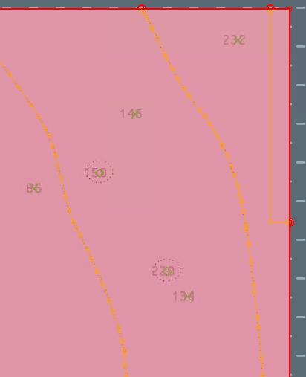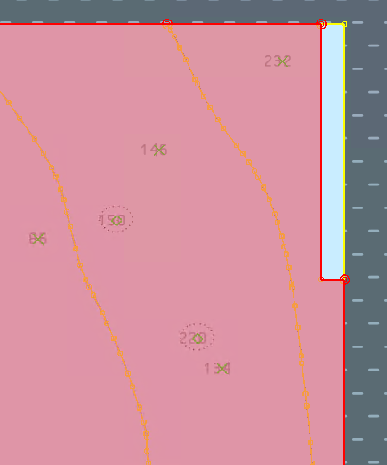  DataCoverage #1 DataCoverage #2
Expected Test Results | 101_1025: An error “ENC contains overlapping DataCoverage meta features.” must be triggered.
Secondary Critical Errors | None

Dataset Name | 10100AA158003 |  |  | S‐158 Check |  | 101_0004 |  |  | Type |  | C
S-158 Description | For each curve segment referenced by only one DataCoverage AND is also shared by more than one Skin of the Earth feature.
Message | Boundary of DataCoverage is shared by more than 1 skin of the earth feature.
Solution | Ensure curve segments on the DataCoverage boundary only reference one Skin of the Earth feature. |  |  |  |  | Conformity |  | PS 4.3.2.1.1
Test Case No. 1 | Skin of the earth features do not equal the DataCoverage.
Location |  | Feature | Attributes |  | FRID |  | FOID |  |  | VRID
32.343559580S, 61.678114736E |  | DataCoverage | maximumDisplayScale 12000  minimumDisplayScale 180000  optimumDisplayScale 45000 |  | 3 |  | 1810:2053:1
Screen Capture | 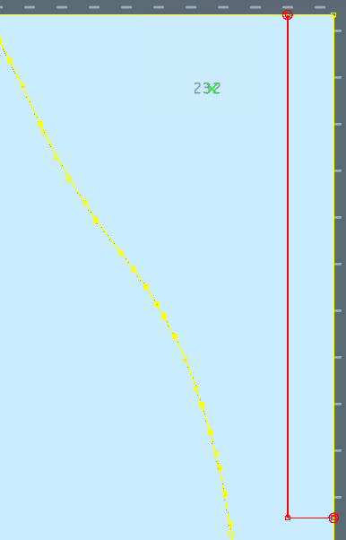
Expected Test Results | 101_0004: An error “Boundary of DataCoverage is shared by more than 1 skin of the earth feature.” must be triggered.
Secondary Critical Errors | None

Dataset Name | 10100AA158003 |  |  | S‐158 Check |  | 101_1182 |  |  | Type |  | C
S-158 Description | For each Gate where verticalClearanceOpen.verticalClearanceUnlimited is False and verticalClearanceOpen.verticalClearanceValue is not Present
Message | verticalClearanceValue must be present if verticalClearanceUnlimited is False.
Solution | Populate verticalClearanceValue OR set verticalClearanceUnlimited to True |  |  |  |  | Conformity |  | PS 8.11.1
Test Case No. 1 | verticalClearanceValue must be present if verticalClearanceUnlimited is False.
Location |  | Feature | Attributes |  | FRID |  | FOID |  |  | VRID
32.378492078S, 61.632884490E |  | Gate | horizontalClearanceValue 1  verticalClearanceUnlimited false |  | 65 |  | 1810:8875:1
Screen Capture | 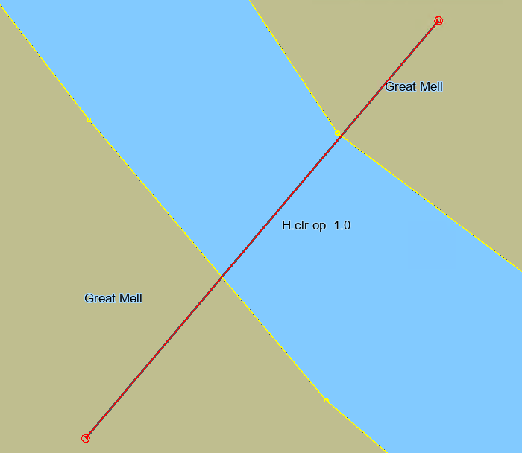
Expected Test Results | 101_1182: An error “verticalClearanceValue must be present if verticalClearanceUnlimited is False.” must be triggered.
Secondary Critical Errors | None

Dataset Name | 10100AA158003 |  |  | S‐158 Check |  | 101_1219 and 101_1204 |  |  | Type |  | C
S-158 Description | 101_1219 – For each DepthContour which does not share a curve with a Skin of the Earth feature AND is WITHIN a DepthArea where depthRangeMinimumValue and depthRangeMaximumValue are Known AND valueOfDepthContour is Less than depthRangeMinimumValue OR Greater than depthRangeMaximumValue.  101_1204 - For each DepthContour which does not share a curve with a Skin of the Earth feature AND is WITHIN a DredgedArea where depthRangeMinimumValue is Known AND valueOfDepthContour is Less than depthRangeMinimumValue.
Message | 101_1219 - Value of floating DepthContour is outside the depth range of the DepthArea which covers it.  101_1204 - Value of floating DepthContour is less than the minimum depth of the DredgedArea which covers it.
Solution | 101_1219 - Amend encoding so that the valueOfDepthContour of the DepthContour is less than the depthRangeMaximumValue and greater than the depthRangeMinimumValue of the covering DepthArea  101_1204 - Amend encoding so that the valueOfDepthContour of the DepthContour is greater than the depthRangeMinimumValue of the covering DepthArea |  |  |  |  | Conformity |  | PS 11.7, 11.4
Test Case No. 1 | Value of floating DepthContour is outside the depth range of the DepthArea which covers it.
Location |  | Feature | Attributes |  | FRID |  | FOID |  |  | VRID
32.394744600S, 61.608027796E  32.393631022S, 61.614683957E |  | DepthContour | valueOfDepthContour 10 m  valueOfDepthContour 50 m |  | 76  77 |  | 1810:8952:1  1810:8953:1
Screen Capture | 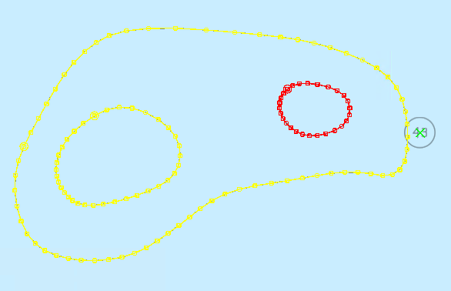
Expected Test Results | 101_1219: An error “Value of floating DepthContour is outside the depth range of the DepthArea which covers it.” must be triggered.
Secondary Critical Errors | None
Test Case No. 2 | Value of floating DepthContour is less than the minimum depth of the DredgedArea which covers it
Location |  | Feature | Attributes |  | FRID |  | FOID |  |  | VRID
32.375172675S, 61.622680002E |  | DepthContour | valueOfDepthContour 8 m |  | 73 |  | 1810:8946:1
Screen Capture | 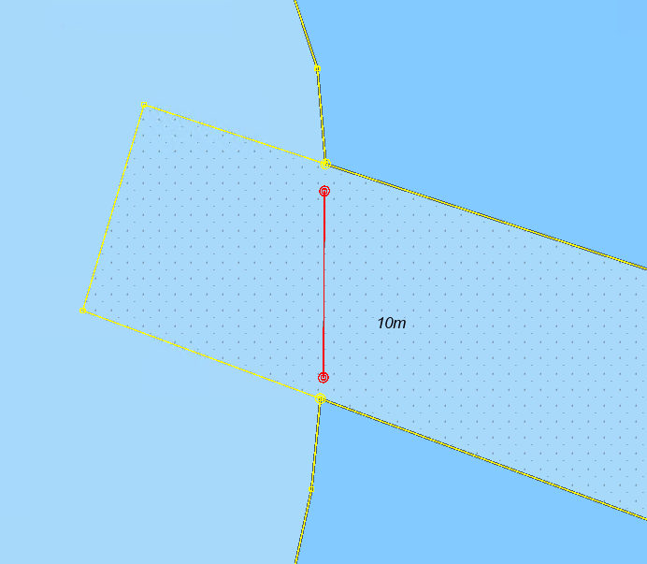
Expected Test Results | 101_1204: An error “Value of floating DepthContour is less than the minimum depth of the DredgedArea which covers it.” must be triggered.
Secondary Critical Errors | None

Dataset Name | 10100AA158003 |  |  | S‐158 Check |  | 101_1209 |  |  | Type |  | C
S-158 Description | For each DepthContour which CROSSES another DepthContour. Instances where the point of intersection is an intermediate vertex or node, and where one DepthContour does not cross to the other side of the other DepthContour, are excluded.
Message | DepthContours cross.
Solution | Amend DepthContour features so they do not cross |  |  |  |  | Conformity |  | PS 11.6
Test Case No. 1 | DepthContours cross.
Location |  | Feature | Attributes |  | FRID |  | FOID |  |  | VRID
32.378759998S, 61.654329375E |  | DepthContour | valueOfDepthContour 100 m  valueOfDepthContour 50 m |  | 69  70 |  | 1810:8949:1  1810:8948:1
Screen Capture | 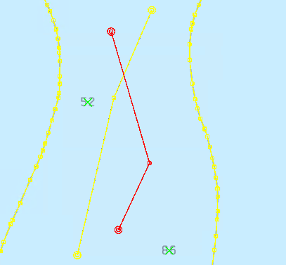
Expected Test Results | 101_1209: An error “DepthContours cross.” must be triggered.
Secondary Critical Errors | None

Dataset Name | 10100AA158003 |  |  | S‐158 Check |  | 101_1229 |  |  | Type |  | C
S-158 Description | For each Wreck OR Obstruction OR UnderwaterAwashRock where valueOfSounding is Known AND defaultClearanceDepth is Known.
Message | Feature where attributes valueOfSounding and defaultClearanceDepth are Known.
Solution | Remove defaultClearanceDepth |  |  |  |  | Conformity |  | PS 13.4, 13.5, 13.6
Test Case No. 1 | Feature where attributes valueOfSounding and defaultClearanceDepth are Known.
Location |  | Feature | Attributes |  | FRID |  | FOID |  |  | VRID
32.340859100S,  61.617503100E  32.341152883S, 61.641820448E  32.341007106S, 61.629320026E |  | Obstruction | defaultClearanceDepth (Unknown)  expositionOfSounding 2 m  surroundingDepth 10 m  valueOfSounding 5 m  waterLevelEffect 3 |  | 81  89  90 |  | 1810:8974:1  1810:8976:1  1810:8970:1
32.348526485S, 61.659499820E |  | Obstruction | defaultClearanceDepth 250 m  surroundingDepth 100 m  valueOfSounding 150 m  waterLevelEffect 3 |  | 91 |  | 1810:8982:1
32.356869530S, 61.666573271E |  | UnderwaterAwashRock | defaultClearanceDepth 230 m  surroundingDepth 100 m  valueOfSounding 220 m  waterLevelEffect 3 |  | 92 |  | 1810:8983:1
32.367479707S, 61.669837941E |  | Wreck | defaultClearanceDepth 55 m  surroundingDepth 100 m  valueOfSounding 50 m  waterLevelEffect 3 |  | 112 |  | 1810:8984:1
Screen Capture | 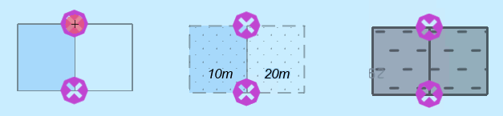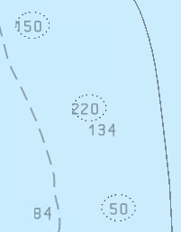
Expected Test Results | 101_1229: An error “Feature where attributes valueOfSounding and defaultClearanceDepth are Known.” must be triggered.
Secondary Critical Errors | None

Dataset Name |  | 10100AA158003 |  | S‐158 Check |  | 101_1239 |  |  | Type |  | C
S-158 Description |  | For each Obstruction OR UnderwaterAwashRock OR Wreck feature of geometric primitive point which TOUCHES a curve referenced by at least two DepthArea, DredgedArea or UnsurveyedArea instances.
Message |  | Point feature lies on the boundary between Skin of the Earth features.
Solution |  | Amend Skin of the Earth feature geometry so that it does not coincieds the point feature. |  |  |  | Conformity |  | PS 13.4, 13.5, 13.6
Test Case No. 1 |  | Point feature lies on the boundary between Skin of the Earth features.
Location | Feature |  | Attributes |  | FRID |  | FOID |  |  | VRID
32.340859100S, 061.617503100E | Obstruction |  | defaultClearanceDepth (Unknown)  expositionOfSounding 2  surroundingDepth 100 m  valueOfSounding 50 m  waterLevelEffect 3 |  | 81 |  | 1810:8974:1
32.344847600S, 061.629311000E | UnderwaterAwashRock |  | expositionOfSounding 2  surroundingDepth 100 m  valueOfSounding 50 m  waterLevelEffect 3 |  | 82 |  | 1810:8971:1
32.344952500S, 061.641853700E | UnderwaterAwashRock |  | expositionOfSounding 2  surroundingDepth 100 m  valueOfSounding 50 m  waterLevelEffect 3 |  | 84 |  | 1810:8977:1
32.344742600S, 061.617503100E | UnderwaterAwashRock |  | expositionOfSounding 2  surroundingDepth 100 m  valueOfSounding 50 m  waterLevelEffect 3 |  | 86 |  | 1810:8975:1
32.341069000S, 061.641853700E | Obstruction |  | defaultClearanceDepth (Unknown)  expositionOfSounding 2  surroundingDepth 100 m  valueOfSounding 50 m  waterLevelEffect 3 |  | 89 |  | 1810:8976:1
32.340964100S, 061.629311000E | Obstruction |  | defaultClearanceDepth (Unknown)  expositionOfSounding 2  surroundingDepth 100 m  valueOfSounding 50 m  waterLevelEffect 3 |  | 90 |  | 1810:8970:1
Screen Capture |  | 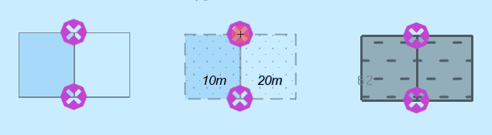
Expected Test Results |  | 101_1239: An error “Point feature lies on the boundary between Skin of the Earth features.” must be triggered.
Secondary Critical Errors |  | None

